Package Management

Overview
There are two ways to install a package in Red Hat-based Linux systems:
* RPM (Redhat Package Manager)
* YUM (Yellowdog Updater, Modified)
RPM stands for Redhat Package Manager and uses .rpm files for packages.

Package Syntax
Format: packagename-Version-Release.architecture.ext
Example: httpd-2.4.6-97.el7.centos.x86_64.rpm

Basic Commands
- Check installed block devices:
# lsblk
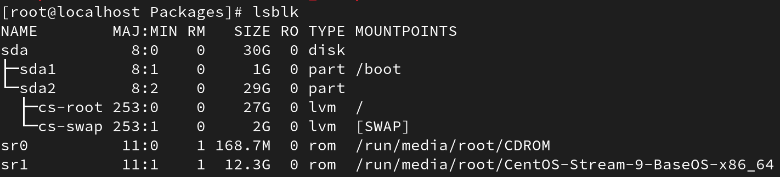
2. List contents of a directory and count words/lines:
# ls | wc (word count)
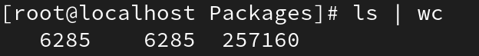
#ls | wc -l (line)
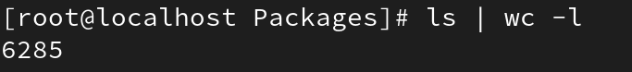

#ls | wc – w (words)
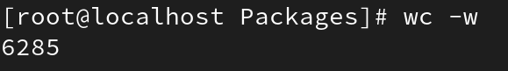
#ls | wc -c (charecters)

Installing Packages
# rpm -ivh <packagename>.rpm
- Installs a package with verbose and hash progress. All dependencies must be met.
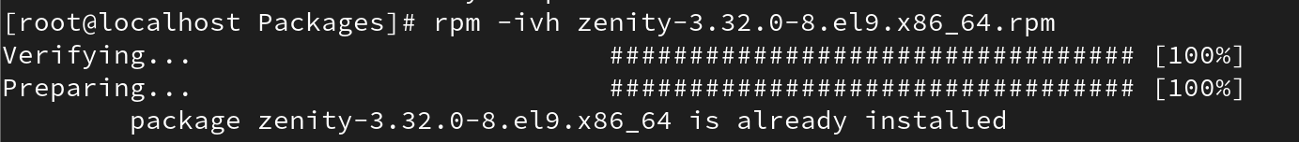

Listing Installed Packages
# rpm -qa
- Lists all installed packages.
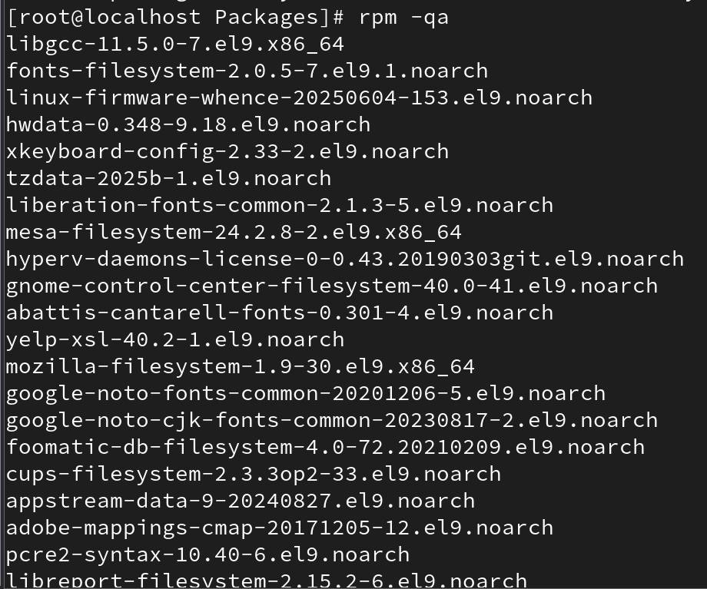
# rpm -q | grep <package>
- Checks if a specific package is installed.

Checking Dependencies
# rpm -qpr <package.rpm>
- Lists capabilities and dependencies of an RPM package.
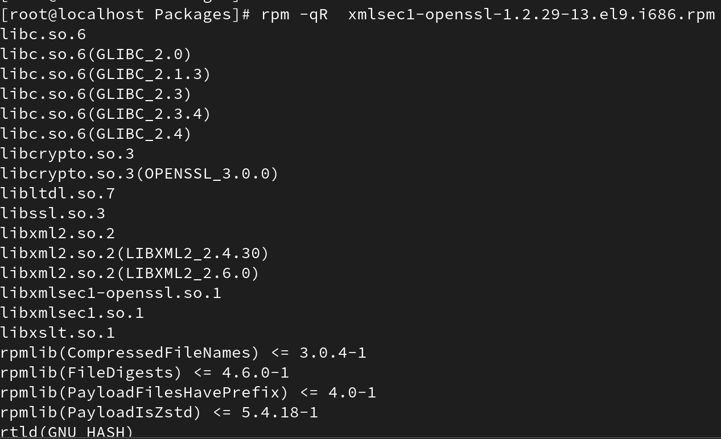
-q : Query a package
-p : Query an uninstalled package file
-R : List capabilities on which the package depends

List Files of Installed Package
# rpm -ql <package>
- Lists all files installed by a package.
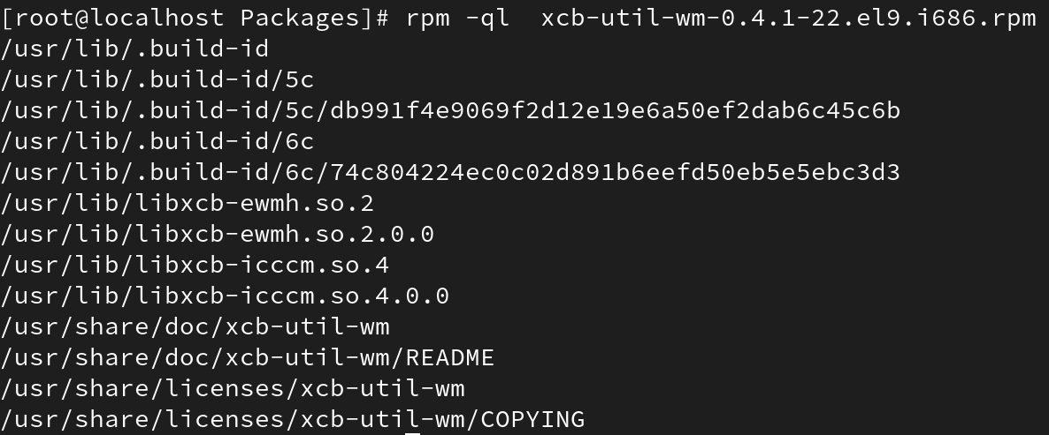

To see last installed date
#rpm -ra –last
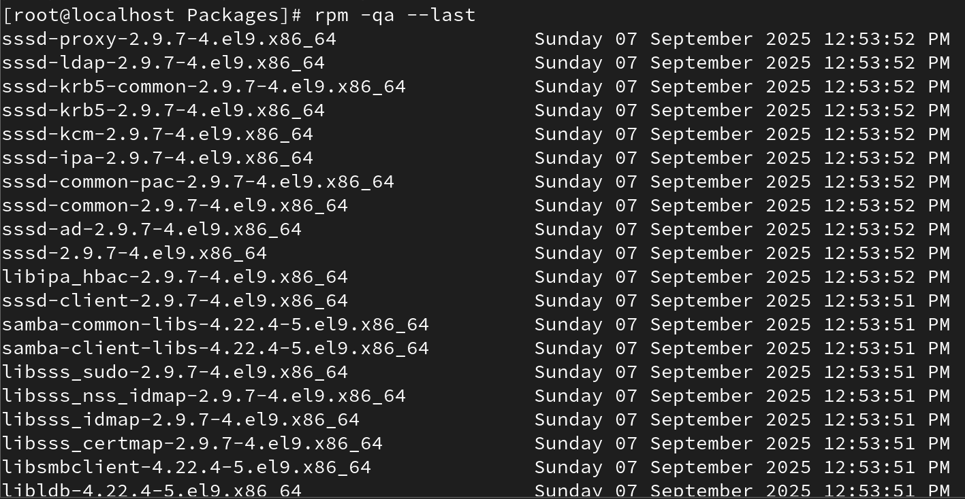
To upgrade
# rpm -Uvh packagename
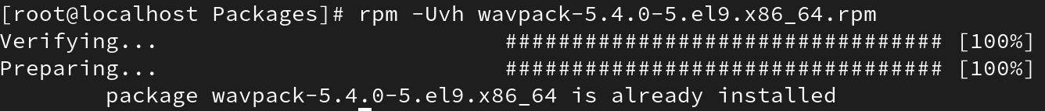

Removing Packages
# rpm -evh <package>
- Removes a package.
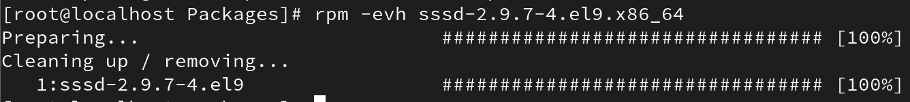
# rpm -evh --nodeps <package>
- Removes a package without removing dependencies.
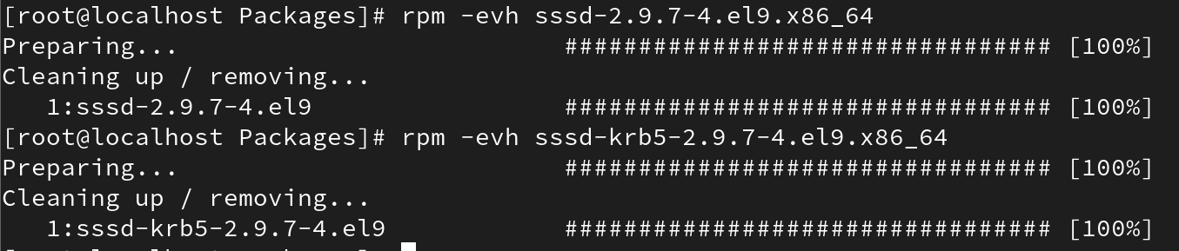

Find Package for a Command
# rpm -qf /usr/bin/mkdir
- Finds which package provides a specific command or file.

Query Information of Installed Package
# rpm -qi <package>
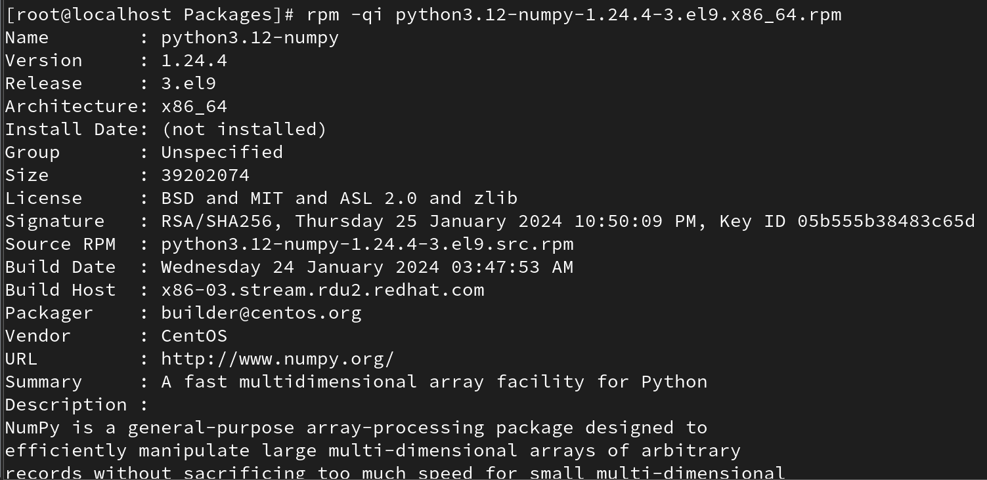
- Displays information about an installed package.
Example: mkdir's package is coreutils.

Query Before Installing
# rpm -qlp <package.rpm>
- Lists files in an RPM before installing.
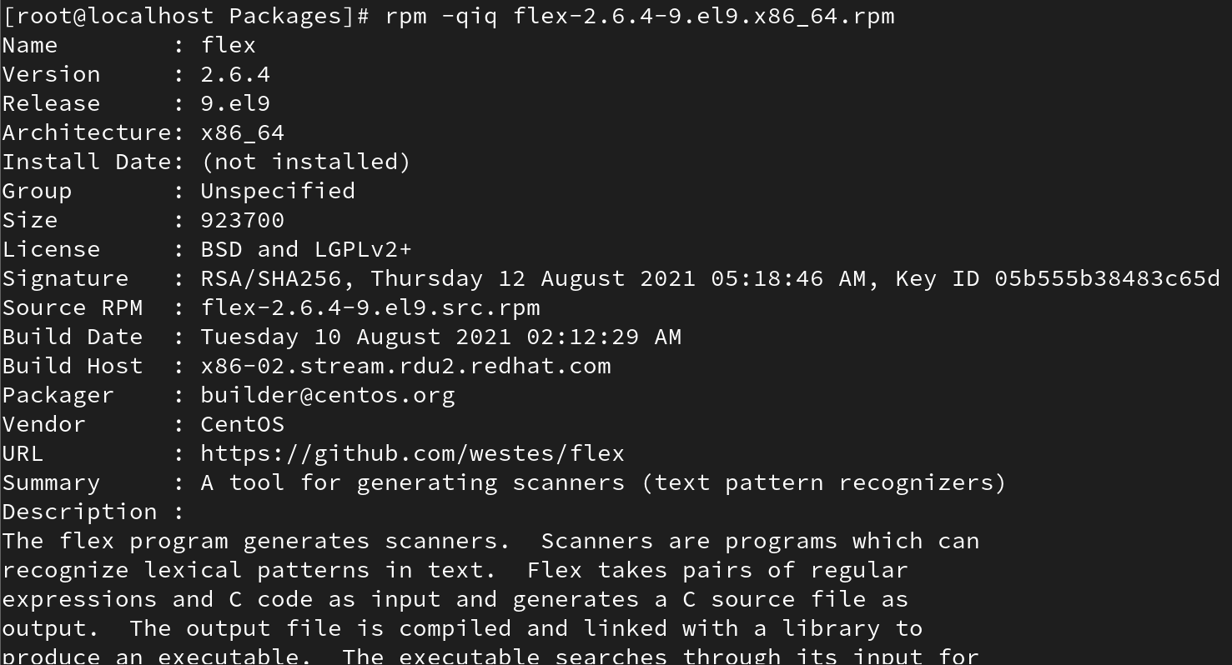
# rpm -qdp <package.rpm>
- Lists documentation files in an RPM before installing.
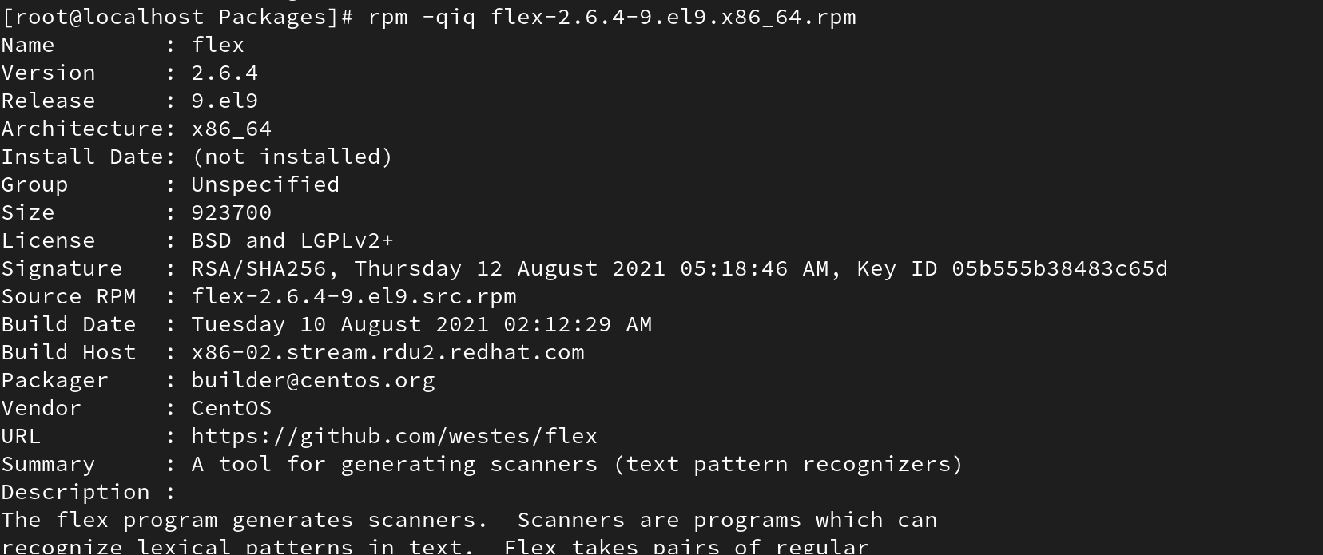
# rpm -qcp <package.rpm>
- Lists configuration files in an RPM before installing.

Query Documentation of Installed Package
# rpm -qdf <package>
- Lists documentation files installed with a package.
